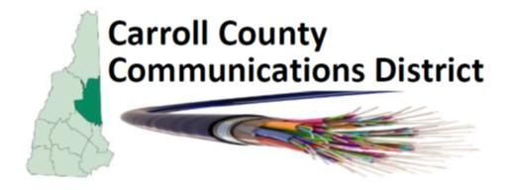

Carroll County Communication District (CCCD)
January 21, 2026 Meeting Minutes
Location: Annex Meeting Room, Carroll County Complex, 10 County Farm Rd., Ossipee, NH 03864
Meeting was called to order by CCCD Chairperson John Gallagher at approximately 10:00 AM.

Roll Call:
Governing Board Members present, Rick Hiland, Stanley Dudrick, Ben Klaus, John Gallagher, David Walker, Bill Lord, Bill Gassman, Sherryl Hitte, Pam Hearne, Bob Murray
Governing Board Members present on ZOOM (4), Sara Knox, Bert Weiss, William Terry, Jean Beadle
NOTE: 10 of 16 towns were represented at today’s meeting.
The (8) voting Governing Board Town Members present in person did not make a quorum so the meeting is for information only (no business that requires a vote).
Discussion of Minutes: Minutes of the October 08,2025 Meeting cannot be voted upon since there is no quorum but we discussed content and noted that there should be an amendment to include 2 motions that were carried unanimously. Minutes will be amended before the next meeting.
Discussion of By-Laws: concerning quorum, we currently need a total of 9, which is a majority of the 16 member towns, to be represented in person in order to make a quorum for our meetings. Given the complexities involved in changing the requirements we believe it is not worth the effort.
Discussion of Treasurer’s Report: Treasure’s Report was presented by Sherryl Hitte. Bills are paid up to date and nothing new is expected to require a vote before our next meeting.
Discussion of SB-585: Rick Hiland gave an update stating that he and Matt Plache have been working on wording the request and suggested all CCCD reps should go online and show support of the bill and contact local state representatives to voice support. There is to be a public hearing in Concord but the date has not yet been determined.
Additional discussion of steps moving forward: Bill Gassman has been providing some internet training lectures at libraries. He has also been working with AI platforms.
Next Meeting: 2nd Quarter Meeting -April 15, 2026 at 10:00 am (3rd Wednesday) at the Carroll County Annex Meeting room.
Adjournment: With no further items to discuss the chair declared the meeting adjourned at approximately 11:45 am

Respectfully submitted,
David Walker

